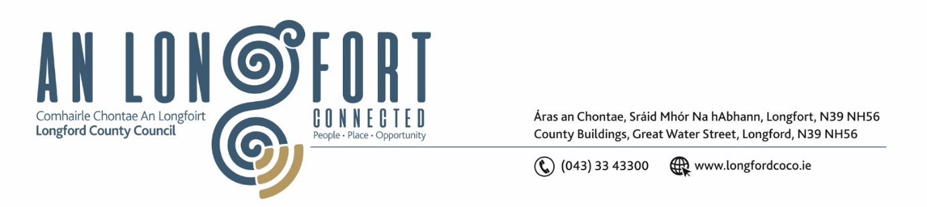

**LONGFORD MUNICIPAL DISTRICT**

***Please note meeting will be held in the Council Chamber, Aras an Chontae and via Microsoft Teams***

**17 May 2023**

**To: Each Member of Longford Municipal District.**

**Dear Member,**

You are requested to attend the Meeting of Longford Municipal District to be held in **the Council Chamber, Aras an Chontae** and **via Microsoft Teams** on **Wednesday 24 May 2023 at 3.30pm** to transact business, as set out on the agenda hereunder.

**Yours sincerely**,

_______________

**Claire McNabola**

**Meetings Administrator**

**AGENDA**

Prayer before meeting.

**1.** Confirmation of Minutes:

1. Longford Municipal District Meeting held on Wednesday 3 May 2023 – enclosed.

**2.** Matters arising from Minutes.

**3.** Declaration of Interest by Members.

**4.** Management Report – to follow.

**5.** Community Grant Support Scheme 2023 – to follow